# **Pre-Test Checks**

1. **File -> Properties** (or) **Ctrl+D**

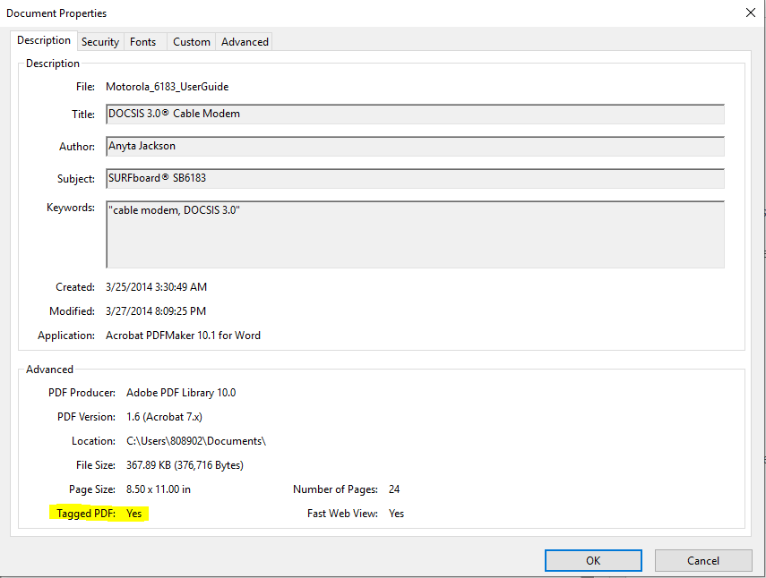

Check for “Tagged PDF: Yes”. If “Yes”, then continue to step 2 otherwise stop testing and request for a tagged PDF document. If PDF is not tagged it cannot be tested.

1. **Click on “Security” tab**

Check for “Content Copying for Accessibility: Allowed”. It is a best practice.

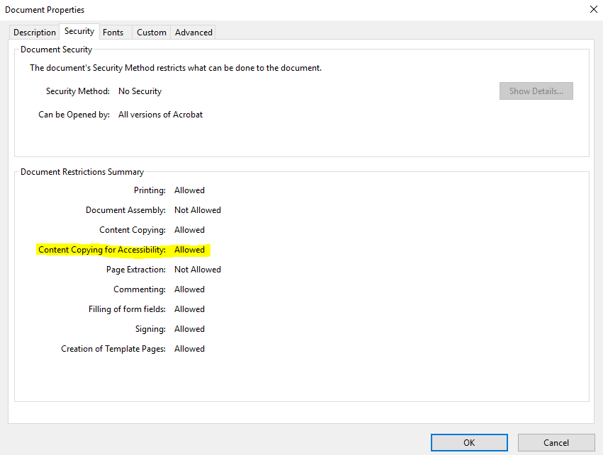

1. **Click on “Advanced” tab**

Check if the “Language” is provided. If not then it fails the guideline *3.1.1 Language of Page*.

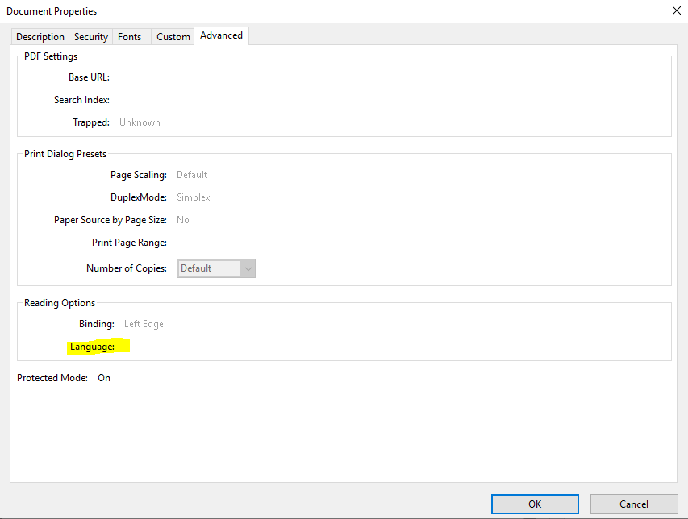

1. **Ensure the following settings are kept**

Edit -> Accessibility -> Setup Assistant…

Choose the settings as shown in screenshot.

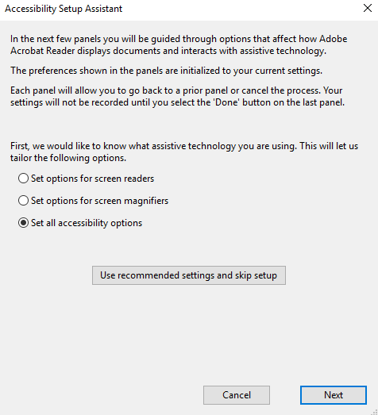

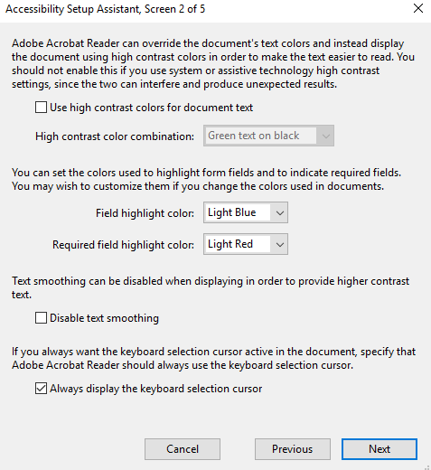

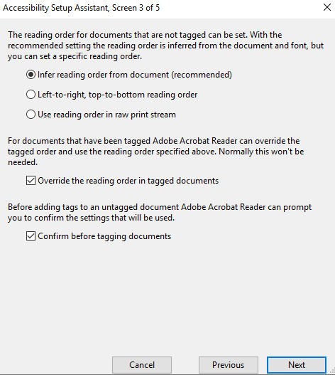

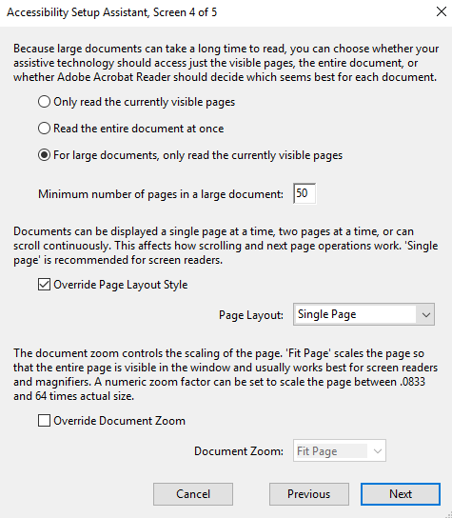

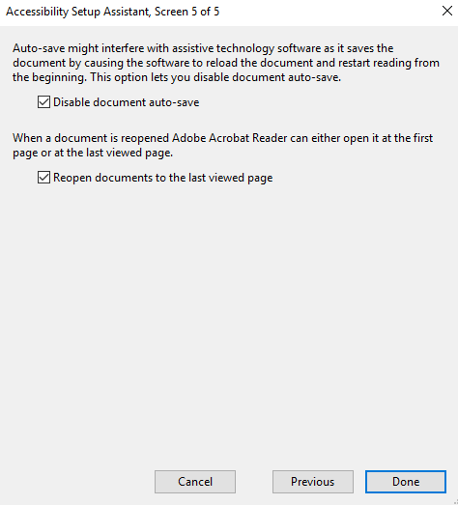

Go to Edit -> Accessibility -> Change Reading option…

Choose the settings as shown in screenshot and click Start.

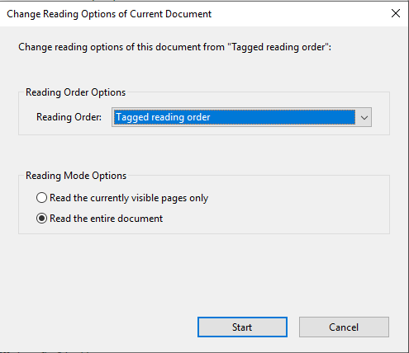

1. **Start testing with NVDA**

View -> Read mode

Switch on NVDA and navigate

# **Checklist for PDF Accessibility**

## **Section A: All PDFs**

These checks should be performed on all PDFs no matter of what is present in the actual content:

| **ID** | **Requirements** | **Guideline** | **Result** |
| --- | --- | --- | --- |
| A1 | Is the PDF tagged? | [WCAG 2.0 Success Criterion 1.3.1](http://www.w3.org/TR/UNDERSTANDING-WCAG20/content-structure-separation-programmatic.html) [exit disclaimer icon](https://www.hhs.gov/disclaimer.html) |  |
| A2 | Is the Document Title filled out in the Document Properties? | [WCAG 2.0 Success criterion 2.4.2](http://www.w3.org/TR/UNDERSTANDING-WCAG20/navigation-mechanisms-title.html) [exit disclaimer icon](https://www.hhs.gov/disclaimer.html) |  |
| A3 | Is the correct language of the document set? | [WCAG 2.0 Success criterion 3.1.1](https://www.w3.org/TR/UNDERSTANDING-WCAG20/meaning-doc-lang-id.html) [exit disclaimer icon](https://www.hhs.gov/disclaimer.html) |  |
| A4 | Did the PDF fully pass the Adobe Accessibility Checker? | [WCAG 2.0 Success Criterion 4.1.1](http://www.w3.org/TR/UNDERSTANDING-WCAG20/ensure-compat-parses.html) [exit disclaimer icon](https://www.hhs.gov/disclaimer.html) |  |
| A5 | Is the document free from content that flashes more than 3 times per second? | [WCAG 2.0 Success Criterion 2.3.1.](http://www.w3.org/TR/UNDERSTANDING-WCAG20/seizure-does-not-violate.html) [exit disclaimer icon](https://www.hhs.gov/disclaimer.html) |  |
| A6 | Are accurate bookmarks provided for documents greater than 9 pages? | [WCAG 2.0 Success Criterion 2.4.5.](http://www.w3.org/TR/UNDERSTANDING-WCAG20/navigation-mechanisms-mult-loc.html) [exit disclaimer icon](https://www.hhs.gov/disclaimer.html) |  |
| A7 | Is the document free from review-related content carried over from Office or other editing tools such as comments, track changes, embedded Speaker Notes? | [WCAG 2.0 Success Criterion 1.3.1](http://www.w3.org/TR/UNDERSTANDING-WCAG20/content-structure-separation-programmatic.html) [exit disclaimer icon](https://www.hhs.gov/disclaimer.html) |  |
| A8 | Is the order in the tag structure accurate and logical? Do the tags match the order they should be read in? | [WCAG 2.0 Success Criterion 1.3.2.](https://www.w3.org/TR/UNDERSTANDING-WCAG20/content-structure-separation-sequence.html) [exit disclaimer icon](https://www.hhs.gov/disclaimer.html) |  |
| A9 | Is all informational content contained in the tag structure? | [WCAG 2.0 Success Criterion 1.3.1](http://www.w3.org/TR/UNDERSTANDING-WCAG20/content-structure-separation-programmatic.html) [exit disclaimer icon](https://www.hhs.gov/disclaimer.html) |  |
| A10 | Are all non-standard tags appropriately mapped to standard Adobe tags? | [WCAG 2.0 Success Criterion 4.1.2](http://www.w3.org/TR/UNDERSTANDING-WCAG20/ensure-compat-rsv.html) [exit disclaimer icon](https://www.hhs.gov/disclaimer.html) |  |
| A11 | Is all the text within the tags correctly formatted? (Free from line breaks and split words) [Learn more about finding and fixing backend text errors](https://www.hhs.gov/web/section-508/making-files-accessible/finding-and-fixing-backend-errors.html). | [WCAG 2.0 Success Criterion 4.1.1](http://www.w3.org/TR/UNDERSTANDING-WCAG20/ensure-compat-parses.html) [exit disclaimer icon](https://www.hhs.gov/disclaimer.html) |  |
| A12 | Do paragraph tags accurately represent visual paragraphs? | [WCAG 2.0 Success Criterion 1.3.1](http://www.w3.org/TR/UNDERSTANDING-WCAG20/content-structure-separation-programmatic.html) [exit disclaimer icon](https://www.hhs.gov/disclaimer.html) |  |
| A13 | Can text be resized and considered readable when magnified to 200%? | [WCAG 2.0 Success Criterion 1.4.4](http://www.w3.org/TR/UNDERSTANDING-WCAG20/visual-audio-contrast-scale.html) [exit disclaimer icon](https://www.hhs.gov/disclaimer.html). |  |

## **Section B: PDFs containing Color**

| **ID** | **Requirements** | **Guideline** | **Result** |
| --- | --- | --- | --- |
| B1 | Is information conveyed by methods other than color alone? | [WCAG 2.0 Success Criterion 1.4.1](http://www.w3.org/TR/UNDERSTANDING-WCAG20/visual-audio-contrast-without-color.html) [exit disclaimer icon](https://www.hhs.gov/disclaimer.html). |  |
| B2 | Does all text (with the exception of logos) have a contrast ratio of 4.5:1 or greater no matter the size? | [WCAG 2.0 Success Criterion 1.4.3](http://www.w3.org/TR/UNDERSTANDING-WCAG20/visual-audio-contrast-contrast.html) [exit disclaimer icon](https://www.hhs.gov/disclaimer.html). (Size stipulation not considered by HHS) |  |

## **Section C: PDFs containing Links**

| **ID** | **Requirements** | **Guideline** | **Result** |
| --- | --- | --- | --- |
| C1 | Are links tagged correctly in the tag structure? (Contain visual link text and link OBJR within the Link tag) | [WCAG 2.0 Success Criterion 1.3.1](http://www.w3.org/TR/UNDERSTANDING-WCAG20/content-structure-separation-programmatic.html) [exit disclaimer icon](https://www.hhs.gov/disclaimer.html). |  |
| C2 | Are links distinguished by a method other than color? | [WCAG 2.0 Success Criterion 1.4.1,](http://www.w3.org/TR/UNDERSTANDING-WCAG20/visual-audio-contrast-without-color.html) [exit disclaimer icon](https://www.hhs.gov/disclaimer.html) |  |
| C3 | Can all link text be understood out of context? If not, does generic link have sufficient context? | [WCAG 2.0 Success Criterion 2.4.4](http://www.w3.org/TR/UNDERSTANDING-WCAG20/navigation-mechanisms-refs.html) [exit disclaimer icon](https://www.hhs.gov/disclaimer.html), |  |

## **Section D: PDFs containing Images**

| **ID** | **Requirements** | **Guideline** | **Result** |
| --- | --- | --- | --- |
| D1 | Are all images conveying information tagged as figures and included in the tag structure? | [WCAG 2.0 Success Criterion 1.3.1](http://www.w3.org/TR/UNDERSTANDING-WCAG20/content-structure-separation-programmatic.html) [exit disclaimer icon](https://www.hhs.gov/disclaimer.html). |  |
| D2 | Do all images conveying information have alt text that provides the same level of understanding a visual user would gain? | [WCAG 2.0 Success Criterion 1.1.1](http://www.w3.org/TR/UNDERSTANDING-WCAG20/text-equiv-all.html) [exit disclaimer icon](https://www.hhs.gov/disclaimer.html). |  |
| D3 | Are all decorative images tagged as artifact/background? | [WCAG 2.0 Success Criterion 1.1.1](http://www.w3.org/TR/UNDERSTANDING-WCAG20/text-equiv-all.html) [exit disclaimer icon](https://www.hhs.gov/disclaimer.html). |  |
| D4 | Do complex images have an alternate accessible means of understanding? | [WCAG 2.0 Success Criterion 1.1.1](http://www.w3.org/TR/UNDERSTANDING-WCAG20/text-equiv-all.html) [exit disclaimer icon](https://www.hhs.gov/disclaimer.html). |  |
| D5 | Is the document free from images of text? (Picture of an informational table, screenshot of text from another source, etc.) | [WCAG 2.0 Success Criterion 1.4.5](http://www.w3.org/TR/UNDERSTANDING-WCAG20/visual-audio-contrast-text-presentation.html) [exit disclaimer icon](https://www.hhs.gov/disclaimer.html) |  |
| D6 | Are groups of related images tagged in a way assistive technology users would understand? | [WCAG 2.0 Success Criterion 1.1.1](http://www.w3.org/TR/UNDERSTANDING-WCAG20/text-equiv-all.html) [exit disclaimer icon](https://www.hhs.gov/disclaimer.html). |  |

## **Section E: PDFs containing Tables**

| **ID** | **Requirements** | **Guideline** | **Result** |
| --- | --- | --- | --- |
| E1 | Does the document use table tags only for data tables? | [WCAG 2.0 Success Criterion 1.3.1.](http://www.w3.org/TR/UNDERSTANDING-WCAG20/content-structure-separation-programmatic.html) [exit disclaimer icon](https://www.hhs.gov/disclaimer.html) |  |
| E2 | Does the table structure in the tag tree match the visual table layout? | [WCAG 2.0 Success Criterion 1.3.1.](http://www.w3.org/TR/UNDERSTANDING-WCAG20/content-structure-separation-programmatic.html) [exit disclaimer icon](https://www.hhs.gov/disclaimer.html) |  |
| E3 | Are all header cells tagged with the TH tag? Are all data cells tagged with the TD tag? | [WCAG 2.0 Success Criterion 1.3.1.](http://www.w3.org/TR/UNDERSTANDING-WCAG20/content-structure-separation-programmatic.html) [exit disclaimer icon](https://www.hhs.gov/disclaimer.html) |  |
| E4 | Do all Header cells contain text? | [WCAG 2.0 Success Criterion 1.3.1.](http://www.w3.org/TR/UNDERSTANDING-WCAG20/content-structure-separation-programmatic.html) [exit disclaimer icon](https://www.hhs.gov/disclaimer.html) |  |
| E5 | Are merged cells correctly spanned with Colspan and/or Rowspan? | [WCAG 2.0 Success Criterion 1.3.1.](http://www.w3.org/TR/UNDERSTANDING-WCAG20/content-structure-separation-programmatic.html) [exit disclaimer icon](https://www.hhs.gov/disclaimer.html) |  |
| E6 | Do data tables with 1 set of both column and row headers appropriately use scope to associate to data cells? | [WCAG 2.0 Success Criterion 1.3.1.](http://www.w3.org/TR/UNDERSTANDING-WCAG20/content-structure-separation-programmatic.html) [exit disclaimer icon](https://www.hhs.gov/disclaimer.html) |  |
| E7 | Do data tables with more than 1 set of column and/or row headers appropriately use id/headers to associate to data cells? | [WCAG 2.0 Success Criterion 1.3.1.](http://www.w3.org/TR/UNDERSTANDING-WCAG20/content-structure-separation-programmatic.html) [exit disclaimer icon](https://www.hhs.gov/disclaimer.html) |  |

## **Section F: PDFs containing Lists**

| **ID** | **Requirements** | **Guideline** | **Result** |
| --- | --- | --- | --- |
| F1 | Are all visual lists tagged correctly with the List, List Item (LI), and LBody tags? | [WCAG 2.0 Success Criterion 1.3.1.](http://www.w3.org/TR/UNDERSTANDING-WCAG20/content-structure-separation-programmatic.html) [exit disclaimer icon](https://www.hhs.gov/disclaimer.html) |  |
| F2 | Does the number of items in the tag structure match the number of items in the visual list? | [WCAG 2.0 Success Criterion 1.3.1.](http://www.w3.org/TR/UNDERSTANDING-WCAG20/content-structure-separation-programmatic.html) [exit disclaimer icon](https://www.hhs.gov/disclaimer.html) |  |
| F3 | Are nested lists appropriately nested in the tag structure? | [WCAG 2.0 Success Criterion 1.3.1.](http://www.w3.org/TR/UNDERSTANDING-WCAG20/content-structure-separation-programmatic.html) [exit disclaimer icon](https://www.hhs.gov/disclaimer.html) |  |

## **Section G: PDFs containing Headings**

| **ID** | **Requirements** | **Guideline** | **Result** |
| --- | --- | --- | --- |
| G1 | Is text intended to act as a visual heading tagged with the heading tags (H1 through H6)? | [WCAG 2.0 Success Criterion 1.3.1.](http://www.w3.org/TR/UNDERSTANDING-WCAG20/content-structure-separation-programmatic.html) [exit disclaimer icon](https://www.hhs.gov/disclaimer.html) |  |
| G2 | Do heading tags follow a logical hierarchical progression? (Do not skip heading levels) | [WCAG 2.0 Success Criterion 1.3.1.](http://www.w3.org/TR/UNDERSTANDING-WCAG20/content-structure-separation-programmatic.html) [exit disclaimer icon](https://www.hhs.gov/disclaimer.html) |  |
| G3 | Are heading tags used only on text that defines a section of content? | [WCAG 2.0 Success Criterion 1.3.1.](http://www.w3.org/TR/UNDERSTANDING-WCAG20/content-structure-separation-programmatic.html) [exit disclaimer icon](https://www.hhs.gov/disclaimer.html) |  |
| G4 | Does the Heading text accurately describe the sectional content? | [WCAG 2.0 Success Criterion 2.4.6](http://www.w3.org/TR/UNDERSTANDING-WCAG20/navigation-mechanisms-descriptive.html) [exit disclaimer icon](https://www.hhs.gov/disclaimer.html) |  |

## **Section H: PDFs containing Forms**

| **ID** | **Requirements** | **Guideline** | **Result** |
| --- | --- | --- | --- |
| H1 | Are all form fields correctly tagged? | [WCAG 2.0 Success Criterion 3.3.2](http://www.w3.org/TR/UNDERSTANDING-WCAG20/minimize-error-cues.html) [exit disclaimer icon](https://www.hhs.gov/disclaimer.html) |  |
| H2 | Do all form fields contain understandable labels and tooltips? | [WCAG 2.0 Success Criterion 3.3.2](http://www.w3.org/TR/UNDERSTANDING-WCAG20/minimize-error-cues.html) [exit disclaimer icon](https://www.hhs.gov/disclaimer.html) |  |
| H3 | Do tooltips contain all formatting requirements that will be automatically flagged as an error? | [WCAG 2.0 Success Criterion 3.3.2](http://www.w3.org/TR/UNDERSTANDING-WCAG20/minimize-error-cues.html) [exit disclaimer icon](https://www.hhs.gov/disclaimer.html) |  |
| H4 | Are required fields programmatically set? | [WCAG 2.0 Success Criterion 3.3.1](http://www.w3.org/TR/UNDERSTANDING-WCAG20/minimize-error-identified.html) [exit disclaimer icon](https://www.hhs.gov/disclaimer.html) |  |
| H5 | Is the tab order of the form fields logical? | [WCAG 2.0 Success Criterion 1.3.2.](https://www.w3.org/TR/UNDERSTANDING-WCAG20/content-structure-separation-programmatic.html) [exit disclaimer icon](https://www.hhs.gov/disclaimer.html) |  |

## **Section I: PDFs containing other common elements**

| **ID** | **Requirements** | **Guideline** | **Result** |
| --- | --- | --- | --- |
| I1 | Is any nonstandard text (glyph) tagged in an accessible manner? Types of Images | [WCAG 2.0 Success Criterion 1.1.1](http://www.w3.org/TR/UNDERSTANDING-WCAG20/text-equiv-all.html) [exit disclaimer icon](https://www.hhs.gov/disclaimer.html). |  |
| I2 | Was Optical Character Recognition successfully performed on a scanned image document?  Eg:1000 page novel in a book. So should be scanned using OCR and convert into readable text. | [WCAG 2.0 Success Criterion 1.4.5.](http://www.w3.org/TR/UNDERSTANDING-WCAG20/visual-audio-contrast-text-presentation.html) [exit disclaimer icon](https://www.hhs.gov/disclaimer.html) |  |
| I3 | Was the language appropriately set for all foreign words or phrases? | [WCAG 2.0 Success Criterion 3.1.2](http://www.w3.org/TR/UNDERSTANDING-WCAG20/meaning-other-lang-id.html) [exit disclaimer icon](https://www.hhs.gov/disclaimer.html) |  |
| I4 | Is the table of contents tagged with appropriate tags? (TOC, TOC Item (TOCI)) | [WCAG 2.0 Success Criterion 1.3.1.](http://www.w3.org/TR/UNDERSTANDING-WCAG20/content-structure-separation-programmatic.html) [exit disclaimer icon](https://www.hhs.gov/disclaimer.html) |  |
| I5 | Are all internal links/TOC entries functioning correctly (if linked)? | [WCAG 2.0 Success Criterion 2.4.5.](http://www.w3.org/TR/UNDERSTANDING-WCAG20/navigation-mechanisms-mult-loc.html) [exit disclaimer icon](https://www.hhs.gov/disclaimer.html) |  |
| I6 | Are citations and footnotes/endnotes tagged with appropriate tags? (Reference, Note) | [WCAG 2.0 Success Criterion 1.3.1.](http://www.w3.org/TR/UNDERSTANDING-WCAG20/content-structure-separation-programmatic.html) [exit disclaimer icon](https://www.hhs.gov/disclaimer.html) |  |